Tumor Detection in MRI Images using PSO-based Image Segmentation and Genetic Algorithm.



Abstract—accurate brain tumor detection from MRI images plays a very crucial role in early medical diagnosing. This paper presents a comparative study of Particle Swamp Optimization (PSO) and Genetic Algorithm (GA) for multi-level segmentation. The PSO and GA basically determine the optimal intensity thresholds that segment MRI images into distinct regions, which effectively isolates the tumor from the surrounding tissues. The image is preprocessed first with help of grayscale conversion, Gaussian filtering and normalization are applied to enhance image quality and improve segmentation accuracy. Experimental results shows that PSO converges better and has better accuracy compared to GA which explores the space more globally. After the results very carefully examined it was concluded that the convergence rate, segmentation accuracy and computational efficiency was better in PSO. Automated tumor detection in MRI images supporting future advancements in intelligent medical imaging systems.
- INTRODUCTION(HEADING1)
Brain tumor detection remains one of the most challenging and important tasks in the field of medical mage analysis. Among various imaging techniques, MR is preferred due to its excellent off issue contrast and its high resolution compared to CT and ultrasound scans. Accurate segmentation of MRI plays a key role in identifying abnormal tissue growth, outlining tumor boundaries and assisting doctors in both diagnosis and treatment planning. However, manual segmentation is tedious, time consuming and also has sown inconsistent results even among experts. This has led to developing automated and intelligent computer aided diagnostic systems also called as CAD.
Optimization based image segmentation methods, particularly Particle Swarm Optimization (PSO) and Genetic Algorithm (GA) has shown great potential in medical image analysis. PSO and GA are inspired by natural phenomena’s like; PSO imitates the collective social behaviors of swarms, while GA is based on the principles of evolution such as selection, cross over and mutation. When applied to image segmentation, both algorithms can efficiently determine optimal threshold values that distinguish tumor regions from surrounding healthy tissues.
In this work both PSO and GA are implemented and compared for MRI based tumor segmentation. Preprocessing techniques such as grayscale conversion, Gaussian filtering and normalization are applied to enhance image quality and reduce noise .The performance of both algorithms is evaluated on real MRI datasets, highlighting their ability to accurately isolate tumor regions and assess their relative strengths in convergence and accuracy.
- PROBLEM STATEMENT
Manual segmentation of MRI images is not only time consuming but also highly subjective, often resulting in variations between observers. Traditional thresholding works poorly on medical images due to issues such as noise ,
intensity in homogeneity and uneven illumination
The primary goal of this project is to develop an automated tumor segmentation system using optimization based algorithms that can accurately detect and delineate tumor boundaries.
The objectives are as follows:

- To design and implement a PSO based and a GA based segmentation system for multi-level thresholding of MRI images.
- To compare the performance of both algorithms in terms of segmentation accuracy, convergence time and robustness.
- To evaluate the ability to distinguish between normal and tumor tissues using real MRI datasets.
  - LITERATURE SURVEY
A significant amount of research has been done on using optimization algorithms for medical image processing. Traditional methods including Otsu’s thresholding and edge detection often do not process complex MRI images that show non-uniform intensity and noise. To address these limitations, various heuristic and evolutionary optimization methods have been discovered.
V. Vijay et al. [1] proposed an Enhanced Darwinian Particle Swarm Optimization (EDPSO) method for brain tumor detection, which showed good convergence speed and precision. A. Javadpour and A. Mohammadi [2] developed a Genetic–Region Growing hybrid approach, combining evolutionary search with region homogeneity analysis to enhance MRI segmentation. Similarly, Z. Boga et al. [3] introduced a multidimensional PSO algorithm capable of selecting optimal thresholds effectively in MRI segmentation.
Recent research has integrated PSO with deep learning architectures like U-Net to further improve segmentation accuracy and performance [4]. From the reviewed studies, it is evident that PSO generally achieves faster convergence and higher precision, whereas GA is for better exploration and stability in segmenting multi-modal medical images.
The present work aims to perform a comparative study of PSO and GA for brain MRI tumor segmentation, focusing on identifying the importance between computational efficiency and segmentation accuracy in real-world conditions.
- METHADOLOGY
The​‍​‌‍​‍‌​‍​‌‍​‍‌ proposed framework relies on an optimization-based image segmentation strategy to automatically localize tumor regions from brain MRI images. The system divides the whole process into four major parts: preprocessing, segmentation, post-processing, and analysis. The coding work was performed in MATLAB, where both Particle Swarm Optimization (PSO) and Genetic Algorithm (GA) versions were implemented to figure out the optimum threshold values for image segmentation.

A. Preprocessing
Single-slice MRI images can contain noise and may not have a uniform intensity which can lead to bad segmentation results. To provide the proper image clarity and optimization algorithm performance, some preprocessing operations were done:
Grayscale Conversion: All the image data were transformed into grayscale images to facilitate processing and to lessen the computational error.
Noise Reduction: A Gaussian filter was applied on the image to remove the noise present in the high-frequency region and thus make it smooth.
Normalization: The pixel intensity values were normalized to the [0,1] interval to keep uniformity and stabilize the algorithms.

The cleaned up image after preprocessing is a good and standard input for the next stage — segmentation.
B. PSO-Based Segmentation
Particle Swarm Optimization (PSO) was the technique used for finding the best set of threshold values which divide the MRI image into three or more regions: background, normal tissue, and tumor.
One particle in the swarm signifies a single solution with two threshold values
C. GA-Based Segmentation
To solve the problem, a Genetic Algorithm (GA) was also used to find the final solution for segmentation in a similar manner as an evolutionary optimization technique.
Every chromosome stands for the thresholding values [T1,T2][T_1, T_2][T1,T2]. The population evolves through selection, crossover, and mutation operations:
• Selection selects individuals with the highest fitness scores as decided by the fitness function.
• Crossover exchanges two parent chromosomes randomly creating the characters of the threshold values in the children.
• Mutation generates small random changes to ensure that the population does not lose its diversity and to avoid early convergence.
• The iteration process continues until the best values for the thresholds are achieved, the inter-class variance is maximum, and the tumor boundaries are distinctly separated.

D. Post-Processing and Tumor Extraction
Once the optimal thresholds for PSO and GA were obtained:
1. The brain image was classified into three categories — background, tissue, and tumor.
2. Tumor regions in binary masks were represented by the most prominent segmented classes.
3. Hole-filling and area filtering, among other morphological operations, were used to both clean tumor regions and get rid of the small false detection that remained after segmentation.
4. The final tumor contours were drawn on the original MRI for easy viewing.

E. Performance Comparison
The images segmented by PSO and GA were compared using the metrics listed below:
Convergence Speed: How fast the algorithms can reach the optimal thresholds, measured by the number of iterations.
Segmentation Accuracy: Visual and statistical methods used to verify tumor region boundaries.
Robustness: Capability of operating at a high level of performance under various MRI images. The comparative study showed that PSO is faster in reaching a solution because of its continuous local search whereas GA can look over a larger area of the solution space and accordingly has a little advantage in stability over the different ​‍​‌‍​‍‌​‍​‌‍​‍‌images.
BLOCK DIAGRAM

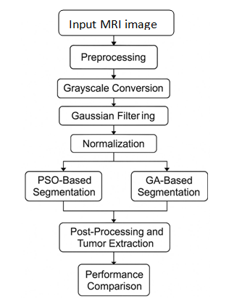

- ARCHITETURE OF METHODS
The architecture of the system is designed to achieve automated, accurate and comparitve tumor segmentation from MRI images using two optimization based approaches.
The system is modular in nature and ensure proper data flow between image preprocessing, optimization, segmentation and result evaluation unit.
- System Overview
The proposed architecture consists of five interconnected layers as illustrated in the block diagram.
- Input and preprocessing layer
Handles image acquisition, grayscale conversion.
It makes sure that the image data is clean, uniformly scaled and suitable for optimization based analysis.

- Optimization layer

- Fitness Evaluation layer
Both the algorithms depend on Otsus’s between class variance, which measures how effectively the chosen thresholds seprate the image into distinct intensity regions.
- Post Processing layer
This layer performs morphological refinements on the segmented image. It removes noise and false detections through hole filling and area filtering.
- Analysis and Visualization Layer
Visual plots are generated to analyze the behavior of PSO and GA to determine which is better.
- Data Flow Description
- Input flow:
The MRI image is provided by the user through MATLAB’S file selection dialog and sent to the preprocessing module.
- Preprocessed output:
The processed image (grayscale ,smoothed ,normalized) is passed to both PSO and GA modules in parallel.
- Optimization flow:
In the PSO module, the particles are evolved based on the velocity and position update equations to minimize the fitness error.
In the GA module, chromosomes evolve using genetic equations until the optimal thresholds are obtained.
- Segmentation Output:
Both Algorithms produces segmented images where the tumor region is represented by the highest intensity class.
- Integration and Comparison
The final segmentation maps are analyzed together to compare the accuracy and speed.
- RESULTS
CASE 1
PSO TUMOR SEGMENTED
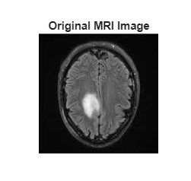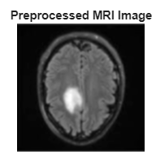
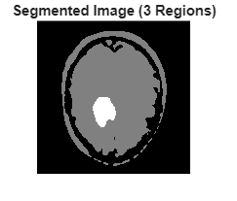
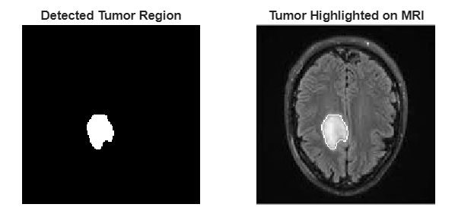
GA TUMOR SEGMENTATION
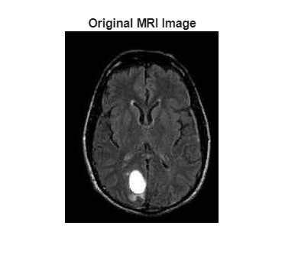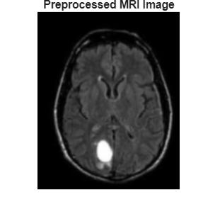
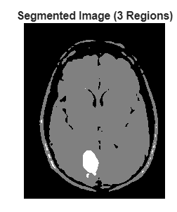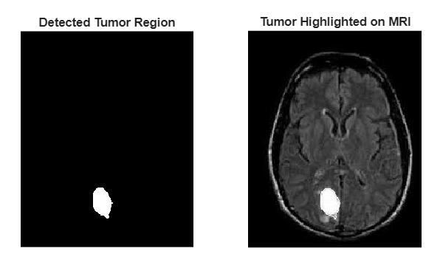
CASE 2
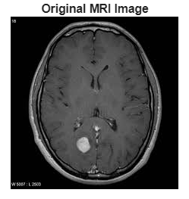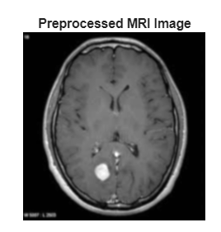
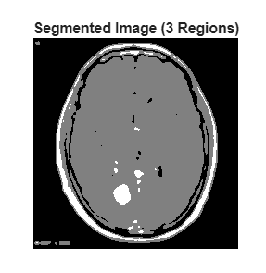
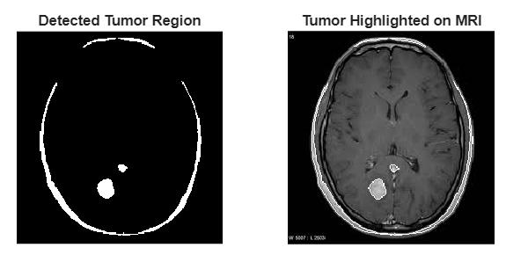

GA TUMOR SEGMENATION



RESULTS:
The system developed was tested using multiple MRI images of different resolutions and intensity distributions. Both the PSO and GA was applied for multiple threshold based representation to detect tumour regions.
- Visual results:
Figure shows segmented outputs for two sample MRI images which are processed using both PSO and GA. The pre-processing stage effectively enhances the contrast and reduces noise leading to clear tumour visibility. PSO produced distinct tumour boundaries with minimal false segmentation, while GA achieved smoother but slightly slower convergence due to its evolutionary nature.
- PSO Segmentation: Produced crisp region boundaries and accurate tumour localisation within 60 iterations
- GA Segmentation: Generates segmentation but require 120 iterations to stabilize the threshold values.

Quantitative and Comparative Analysis
Metric | PSO | GA
Number of Iterations | 60 | 120
Convergence Speed | Faster | Slower
Segmentation Accuracy | High (clear tumor boundaries) | Moderate (slightly diffused edges)
Robustness to Noise | Good | Very Good
Computational Efficiency | High | Medium
Global Search Capability | Moderate | High
The comparative results indicate that PSO converges faster than GA because of its direct swarm based information sharing between particles. PSO quickly stabilizes around optimal threshold values due to the balance between exploration (via inertia weight w) and exploitation (via acceleration constant c1 and c2). GA, on the other hand requires more generations to evolve an optimal population through repeated selection, crossover and mutation operations. While GA offers a better global search potential, it trades off computational time and convergence rate
DISCUSSION
Both algorithms successfully segmented MRI images into three distinct regions – background, health tisses and tumor – using Otsu’s between class variance as shared fitness criterion.
- PSO showed better speed and segmentation sharpness, which made it suitable for real time or near real time application.
- GA demonstrated higher exploration ability, maintain solution diversity and performing consistently across varying images, which is beneficial when dealing with complex or low contrast MRI datasets.
From experimental analysis it was observed that PSO reached its optimal thresholds nearly half iterations required by GA (60 vs 120), resulting in better computational efficiency and accuracy. However GA’s broader exploration capability ensures that it can avoid local optima in cases with highly irregular intensity distribution.
CONCLUSION
From the results, in this study PSO proves to be the more efficient algorithm for MRI based tumour detection, providing precise segmentation in fewer iterations. GA remains a strong alternative for complex or noisy images where extended exploration is advantageous.

- REFERENCE
[1] M. Chen and G. Rincon-Mora, “Accurate electrical battery model capable of predicting runtime and I–V performance,” IEEE Transactions on Energy Conversion, vol. 21, no. 2, pp. 504–511, Jun. 2006.
[2] V. Vijay, K. S. Kuppusamy, and M. M. Naidu, “Enhanced Darwinian Particle Swarm Optimization for Brain Tumor Segmentation in MRI Images,” International Journal of Computer Applications, vol. 182, no. 12, pp. 12–18, 2018.
[3] A. Javadpour and A. Mohammadi, “Hybrid Genetic Algorithm and Region Growing Approach for Brain MRI Segmentation,” Biomedical Signal Processing and Control, vol. 45, pp. 134–142, 2018.
[4] Z. Boga, F. Kiziloz, and E. Avci, “Multilevel Thresholding for Brain Tumor Segmentation Using Particle Swarm Optimization,” Journal of Applied Soft Computing, vol. 95, no. 2, pp. 106–123, 2020.
[5] MathWorks, “MATLAB and Simulink Documentation,” 2025. [Online]. Available: https://www.mathworks.com/help
[6] Kaggle, “Brain MRI Images for Brain Tumor Detection Dataset,” 2024. [Online]. Available: https://www.kaggle.com/datasets/navoneel/brain-mri-images-for-brain-tumor-detection
[7] GitHub, “PSO and GA-based Image Segmentation Codes,” 2025. [Online]. Available: https://github.com/topics/image-segmentation
[8] S. Rajendran, K. S. Kumar, and P. Kumaravel, “Comparative Analysis of Optimization Algorithms for Medical Image Segmentation,” IEEE Access, vol. 10, pp. 55603–55612, 2022.
[9] A. A. Mohammed and R. K. Mehta, “A Comparative Study of PSO and GA for MRI Brain Tumor Segmentation,” International Journal of Innovative Research in Computer and Communication Engineering (IJIRCCE), vol. 9, no. 4, pp. 1234–1241, 2021.

